**Mohsen jalilian**

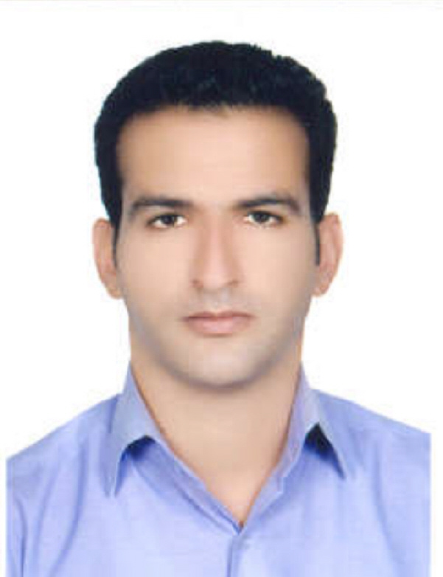

|  |  |
| --- | --- |
| **Contact Information** | [jalilian91@yahoo.com](mailto:jalilian91@yahoo.com)  Tel: +98843 2223071  Fax: +98843 2223071  Address: Ilam University of Medical Sciences, School of Health |
| **Academic Rank:** | Assistant Professor |
| **School:** | Health |

**Education**

1. **B.Sc**

Public Health, Tehran University of Medical Sciences, Tehran, Iran, 2007

2. **MSc**

Health Education, Hamadan University of Medical Sciences, Hamadan, Iran, 2010

3. **Ph.D**

Health Education & Promotion, Isfahan University of Medical Sciences, Isfahan, Iran, 2016

**Language Skills**

1. **English**

Speaking: intermediate level, Reading: advance level, Writing: intermediate level

**Experiences**

1. **Lecture**
2. Department of public health and Education development center (EDC), Ilam University of Medical Sciences, 2010-2012
3. **Assistant Professor**

Department of public Health, Ilam University of Medical Sciences, since 2016

1. **Chief Manager of central library and documentary center of Ilam University of Medical Sciences since 2016**
2. Deputy Director of Education and Graduate Education, Ilam University of Medical Sciences, since 2018

**Course Teaching**

1. **B.Sc**

Principles of health education and communication –research methods in health sciences – public health

**2. MSc**

Health education and promotion–group dynamics- psychology of health behavior- research methods in health sciences- Medical information systems – health communication- media- based health promotion- community- based health promotion

**Papers**

1. Jalilian M, Moeini B, Hazavehei SMM, Beigi AM, Sharifirad G, Nodeh FH. Physical activity stage-matched intervention: Promoting metabolic control in type 2 diabetes. Journal of Education and Health Promotion. 2013;2:18. doi:10.4103/2277-9531.112688.

2. Jalilian F, Hazavehei SM, Vahidinia AA, Jalilian M, A. M. Prevalence and related factors for choosing self-medication among pharmacies visitors based on health belief model in Hamadan Province, west of Iran

3. Jalilian M, Mostafavi F, Delpisheh A, Mahaki B, Rad GS, Mahboubi M, et al. Impacts of using electronic devices on road crossing behaviors among medical college student2014. 391-5 p.

4.Ataee M, Ahmadi-Jouybari T, Ahmadpana M, Jalilian F, Emdadi S, Jalilian M, et al. Perceptual Factors Related to register as Organ Donors among Iranian Medical College Student. Journal of Biology and Today's World. 2014;3(2):28-32.

5.Jalilian M, Mostafavi F, Mahaki B, Delpisheh A, Gh. s. An application of a theory of planned behaviour to determine the association between behavioural intentions and safe road-crossing in college students: perspective from Isfahan, Iran. J Pak Med Assoc 2015 Jul;65(7):742-6.

6.Bahari A, Jalilian M, Sharifirad G, Bazani M. The Impact of Educational Intervention on Aggression Level among High School Students in Ilam-Iran. International Journal of Pediatrics. 2017;5(1):4239-49.

7. Hadi Ehsanbakhsh, Amin Mirzaei, Behzad Mahaki and Mohsen Jalilian, 2016. Stress Management in Type 2 Diabetes: The Role of Self-Eifficacy and Perceived Social Support. *Research Journal of Medical Sciences, 10: 828-833.*

8. Omid Ali Gholami, Mohammad Sadegh Abedzadeh Zavareh, Mohsen Jalilian and Amin Mirzaei, 2016. Student’s Positive and Negative Attitudes Towards the Hookah Tobacco Smoking. *Research Journal of Medical Sciences, 10: 813-816.*

*9.* *Mohammad Sadegh Abedzadeh Zavareh, Mina Hasani, Maryam Darabi, Amin Mirzaei, Ali Khorshidi, Ali Saeidi, Khalil Momeni, Mohsen Jalilian. Growth indicators and nutritional supplement evaluation in 6-12 months year old children’s: A perspective from Ilam. Electron J Gen Med 2018;15(3):em17.*

*10. Leila Zeinivand Moghadam, Mohammad Sadegh Abed Zadeh Zavareh, Mohsen Jalilian, Morteza Mansourian, Mohammad Bazyar, Neda Mokhtari, Amin Mirzaei. Tendency to Rhinoplasty in University Students Based on the Level of Self-Esteem and Body Image Concern.* *Middle east journal of family medicine volume 16 issue 1, january 2018.*

*11. Atefeh Yosefimehr, Mohsen Jalilian, Maedeh Kamalvandi, Nematullah Kurd. Evaluation of Respiratory and Neurobehavioral Symptoms Due To Exposure with Volatile Organic Compounds among Employees of Petrol Stations in Dezful City: A Cross Sectional Study. International Journal of Scientific Study .2017 ,5(3).*

*12.* *Maryam Omidi, Mohsen Jalilian1, Meghdad Kazemi, Maedeh Kamalvandi, Maryam Jamshidzad, Nematullah Kurd.* *Using of Cornell measuring tool (Cornell musculoskeletal discomfort questionnaires) for assessment of the musculoskeletal disorders prevalence among Ilam teaching hospitals nurses: Cross‑sectional study in 2016.* *Annals of Tropical Medicine and Public Health 2017; 10 (6).*

*13. Farnaz Safarpor, Mohsen Jalilian1, Meghdad Kazemi, Maryam Jamshidzad, Maedeh Kamalvandi, Nematullah Kurd. Evaluation of noise effects on standard threshold shift employees*

*of technical and professional organization according to the audiogram and sound overall level measurement in Ilam: A cross‑sectional study. Annals of Tropical Medicine and Public Health 2017; 10 (6).*

|  |
| --- |
|  |

**Skills**

* Design, implementation and evaluation of health education programs
* Instructional design
* Biostatistics analysis

**Research Interests:**

* Participatory research
* Community based health education and promotion
* Health education for adults
* Health education fir patients with diabetes
* Prevention of traffic accidents
* Safe- crossing behaviors
* Diabetes management
* Physical activity